Joins in database

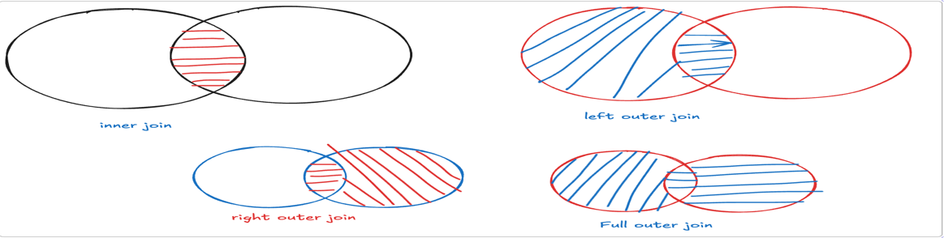

Joins in SQL
- when in the output you need to get data from multiple tables, then we use joins
- there are 3 types of joins, out of these inner join and outer join are most commonly used

cross join | it combines every row of one table with every row in another table
inner join | inner joins will always give you matching rows.  these are of 3 types.  - equi join- if the join condition is based on = operator then it is called as euijoin  - non equi join- if the join condition is based on oerator other than = operator then it is called as non euijoin.  - self join-- when you combine a table with itself then it is called as self join
outer join | outer join always gives you matching and non matching rows  there are 3 type of outer join  - left outer join- if you want to get matching rows and non matching rows from left side table the it is left outer join  - right outer join- if you want to get matching rows and nonmatching rows from right side table the it is right outer join  - full outer join- if you want to get matching rows and nonmatching rows from both side table the it is full outer join, to take full outer join in mysql we need to take union, but in oracle we can use full join

- display all employees empno,ename,deptno,dname
select empno,ename,d.deptno,dname  from emp e,dept d  where e.deptno=d.deptno | select empno,ename,deptno,dname  from emp e inner join dept d  on e.deptno=d.deptno

- display all employees empno,ename,sal and grade
select empno,ename,sal,grade,losal,hisal  from emp e, salgrade s  where sal between losal and hisal; | select empno,ename,sal,grade,losal,hisal  from emp e inner join salgrade s  on sal between losal and hisal;

- display all employees empno,ename,deptno,dname who works in accounting department
select empno,ename,deptno,dname  from emp e,dept d  where e.deptno=d.deptno and d.dname=’ accounting’; | select empno,ename,deptno,dname  from emp e inner join dept d  on e.deptno=d.deptno  where d.dname=’ accounting’;

Select all employee who are working in accounting  Select empno,ename,deptno,sal,grade  From emp  Where deptno = (select deptno  From dept  Where dname=’Accounting’) | Display employeeno, name and department name  Select empno,ename,d.deptno,dname  From emp e, dept d  Where e.deptno=d.deptno

- to display all employees with department name for all employees who works as CLERK

select empno,ename,dname  from emp e, dept d  where e.deptno=d.deptno and job=’CLERK’ | select empno,ename,dname  from emp e inner join dept d  on e.deptno=d.deptno where job=’CLERK’

Display productid,pnameqty and price, cname,cdesc
select pid,pname,qty,price,cname,cdesc from product p , category c where p.catid=c.cid; | select pid,pname,qty,price,cname,cdesc from product p inner join category c on p.catid=c.cid;

- display course id, course name, faculty name and course duration from course and faculty table
Select cid,cname,duration,fname  From course c,faculty f  Where c.fid=f.facid | Select cid,cname,duration,fname  From course c inner join faculty f  on c.fid=f.facid

- display courseid,cname,roomname, duration of the course
Select cid,cname,duration,rname  From course c,room r  Where c.rid=r.roomid | Select cid,cname,duration,rname  From course c inner join room r  on c.rid=r.roomid

- to display course id, course name,duration, room name and faculty name assigned to the course , for all courses with capacity >100
Select cid,cname,duration,rname,fname  From course c,room r,faculty f  Where c.rid=r.roomid and c.fid=f.facid and capacity > 100 | Select cid,cname,duration,rname,fname  From course c join room r on c.rid=r.roomid inner join faculty f  On c.fid=f.facid  Where capacity > 100

- write a query to display cid,cname, room name, also display rooms which are not assigned to the course
Select cid,cname,rname  From course c right join room r  On c.rid=r.roomid; | Select cid,cname,rname  From room r left join course c  On c.rid=r.roomid;

- write a query to display cid,cname, faculty name, also display faculties which are not assigned to the course
Select cid,cname,fname  From course c right join faculty f on c.fid=f.facid; | Select cid,cname,fname  From faculty f left join course c on c.fid=f.facid;

- display cid,cname,rid, rname from course and room table, also display courses for which no room is assigned, and rooms which not assigned to the course;
select cid,cname,rid,roomid,rname from course c left join room r on c.rid=r.roomid
union
select cid,cname,rid,roomid,rname from course c right join room r
on c.rid=r.roomid;

- display all course for which no room is assigned and also display rooms which are not assigned to course
Select cid,cname, null ,null from course  Where rid is null  union  Select null,null,roomid,rname  From room r  Where not exists (select * from course c  Where c.rid=r.roomid); | Select cid,cname,null roomid,null rname  From course c left join room r on  c.rid=r.roomid  where rname is null  union  Select null, null,roomid,rname  From course c right join room r on  c.rid=r.roomid  where cname is null;

- find all rooms which are not assigned to course and also display faculties which are not assigned to any course

Select roomid,rname,null facid,null name  From room r left join course c  On c.rid=r.roomid  Where cname is null  Union  Select null, null,facid,fname  From faculty f left join course c  On c.fid=f.facid  Where cname is null; | Select roomid,rname, null facid,null fname  From room r  Where not exists (select * from course c  Where c.rid=r.roomid)  Union  Select null,null,facid,fname  From faculty f  Where not exists (select * from course c  Where c.fid=f.facid);

- to display all employees empno,ename,dname and also display employees for whom no dept is assigned
select empno,ename,e.deptno,dname  from emp e left join dept d on e.deptno=d.deptno; | select empno,ename,e.deptno,dname  from dept d right join emp e on e.deptno=d.deptno;

- to display all employees empno,ename,dname and also display departments in which no employee is assigned
select empno,ename,e.deptno,dname  from emp e right join dept d on e.deptno=d.deptno; | select empno,ename,e.deptno,dname  from dept d left join emp e on e.deptno=d.deptno;

7. to display all employees empno,ename,dname and also display employees who are not assigned to any department, also display all department in which no employee exists
select empno,ename,e.deptno,dname
from emp e right join dept d on e.deptno=d.deptno
union
select empno,ename,e.deptno,dname
from emp e left join dept d on e.deptno=d.deptno;

- course (cid,cname, duration,roomid,fid)
faculty(fid,fname,subject)
room(rid,rname,rloc)

rid | rname | rloc
100 | mogra | 1 st floor
101 | lotus | 1 st floor
102 | jasmin | 2 nd floor
faculty
fid | fname | subject
1 | Madhura | JAVA
2 | Kishori | Database
3 | Srujana | .net
course
cid | cname | duration | roomid | fid
1000 | DAC | 4 | 100 | 1
1001 | DBDA | 4 | 101 | null
1002 | DTISS | 6 | null | null
- display all faculties who are not assigned to any course and also display rooms which are not assigned to any course

select cname,fid,fname,null roomno,null roomname
from course c right join faculty f on c.fid=f.fid
where cname is null
union
select cname, null,null,rid,rname
from course c right join room r on c.roomid=r.rid
where cname is null

- display cname, rname assigned to it, also display rooms which are available
select cname,rname
from course c right join room r on r.rid=c.roomid;

- display cname, fname assigned to it, also display faculties who are available
select cname,fname
from course c right join faculty f on f.fid=c.fid

- display all courses name, faculty name and rooname assigned to all courses
select cname,fname,rname  from courses c,faculty f, room r  where c.roomid=r.rid and c.fid=f.fid | select cname,fname,rname  from courses c inner join faculty f on c.fid=f.fid inner join room r  on c.roomid=r.rid

- to display cname,rname assigned to each course
select cname,rname  from course c inner join room r on c.roomid=r.rid | select cname,rname  from course c , room r where c.roomid=r.rid

- to display cname, fname, course duration for all courses
select cname,fname,duration  from course c inner join faculty f  on c.fid=f.fid | select cname,fname,duration  from course c , faculty f  where c.fid=f.fid

- write query to display empno,ename, dname, grade for all analysts and managers

- write query to display empno,ename, dname, grade for all employees who works in sales department
Select empno,ename,dname,grade
From emp e inner join dept d on e.deptno=d.deptno inner join salgrade s
On e.sal between s.losal and s.hisal
Where dname =’sales’

- write a query to display pairs of employee, like 1st employees salary < 2 nd employees sal
select e.empno,e.ename,e.sal,m.empno,m.ename,m.sal  from emp e,emp m  where e.sal<m | select e.empno,e.ename,e.sal,m.empno,m.ename,m.sal  from emp e inner join emp m  on e.sal<m.sal
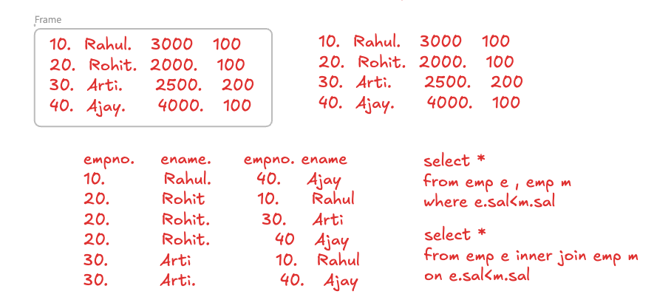
- write query to display pair of products like 1st products mfgdate = 2nd products mfgdate
Select p.pid, p.pname, p.mfgdate, p1.pid, p1.pname, p1.mfgdate  From product p, product p1  Where p.mfgdate=p1.mfgdate | Select p.pid, p.pname, p.mfgdate, p1.pid, p1.pname, p1.mfgdate  From product p inner join product p1  On p.mfgdate=p1.mfgdate
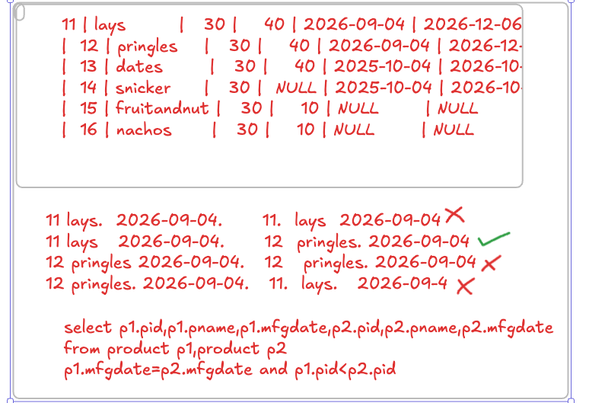
- display all pairs of employees who work under same manager
select e.empno,e.ename,e.mgr,m.empno,m.ename,m.mgr from emp e, emp m where e.mgr=m.mgr and e.empno<m.empno;

- display all grades, which are not assigned to any employee
Select empno,ename,grade,losal,hisal
From emp e right join salgrade s
On e.sal between s.losal and s.hisal
Where ename is null;

- display all faculties who are not assigned to any course and their sp_sub is java
Select facid,fname
From faculty f left join course c
On c.fid=f.facid
Where cname is null and f.sp_sub=’java’

- display all rooms which are not assigned to any course and are at 2nd floor
Select roomid,rname
From room r left join course c on c.rid=r.roomid
Where cname is null and rloc=’2nd floor’

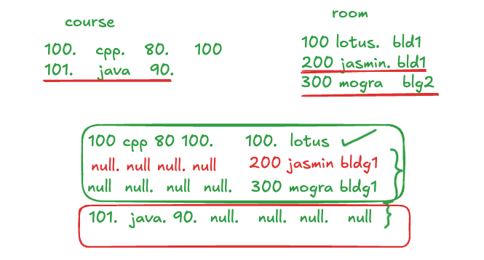
CTE (Common Table Expression)
- it helps to reduce complexity of the query

- Syntax
WITH cte_name AS (
SELECT column1, column2
FROM table_name
WHERE condition
)
SELECT *
FROM cte_name;

- Display all employees with sal > average sal of dept 10
With avg_salary as (select avg(sal) as asal  From emp e  Where deptno=10)  Select e.empno,ename,e.sal,a.asal from emp e , avg_salary a  Where e.sal < a.asal | Select *  From emp  Where sal<(select avg(sal)  From emp e  Where deptno=10);

- Display all employees with sal < avg sal of its own department
With dept_avg as (select deptno,avg(sal) as avg_sal  From emp  Group by deptno)  Select e.empno,e.ename,e.sal,e.deptno,d.deptno,d. avg_sal  From emp e inner join dept_avg d on e.deptno=d.deptno  Where e.sal<d.avg_sal; | Select *  From emp e  Where sal < (select avg(sal)  From emp m  Where m.deptno=e.detno)

